Credit Card AI Fraud Detection
  - Sahil Hirpara

Data Description
Data set name: Credit Card Fraud Detection Dataset (2023)
Source: The dataset is sourced from Kaggle: Credit Card Fraud Detection Dataset.
Description of features: The dataset contains numeric features related to credit card transactions, such as transaction amount, time, and anonymized features (V1, V2, ..., V28) resulting from PCA transformation. The last column represents the classification label (fraud or not fraud).
Classification task: The task is to classify whether a transaction is fraudulent (binary classification).
Statistics:
- Number of features: 30 (28 PCA-transformed features + Time + Amount + Class).
- Number of items in each class: The dataset is highly imbalanced, with a small percentage of fraudulent transactions (e.g., ~0.1% fraud).
- Range of each feature: The PCA-transformed features (V1–V28) are already normalized, while Time and Amount may require scaling.
The Tests

Part 1: Your k-NN
The tests involved implementing a custom k-NN algorithm and comparing it with scikit-learn's k-NN implementation. The data was normalized using StandardScaler, and the same training-testing split was used for both implementations. The dataset was split into 80% training and 20% testing data
 | k=1 | k=3 | k=5
My K-NN | 0.97 | 0.96 | 0.95
SKLearn K-NN | 0.97 | 0.96 | 0.95

Part 2: SKLearn k-Nearest Neighbour Experiments
Brief overview goes here. Describe the parameters you varied and the values you chose (K parameter, voting, distance, normalization, etc.). Describe the testing/training splits (% for each group). How many runs were averaged together?
Answer
The experiments involved tweaking scikit-learn's k-NN parameters, including the number of neighbors (k), weighting scheme (uniform or distance), and distance metric (p=1 for Manhattan, p=2 for Euclidean). The data was normalized, and a 5-fold cross-validation was used to evaluate performance. The results were averaged over 5 runs.

 | Parameter 1 | Parameter 2 | Parameter 3 | Mean AccuRacy | Mean F1
K-NN test 1 | 3 | uniform | 1 | 0.96 | 0.96
K-NN test 2 | 3 | uniform | 1 | 0.96 | 0.96
K-NN test 3 | 3 | distance | 2 | 0.97 | 0.97
K-NN test 4 | 3 | distance | 2 | 0.96 | 0.96
K-NN test 5 | 5 | uniform | 1 | 0.96 | 0.96
K-NN test 6 | 5 | uniform | 1 | 0.96 | 0.96
K-NN test 7 | 5 | distance | 2 | 0.97 | 0.97
K-NN test 8 | 5 | distance | 2 | 0.96 | 0.96
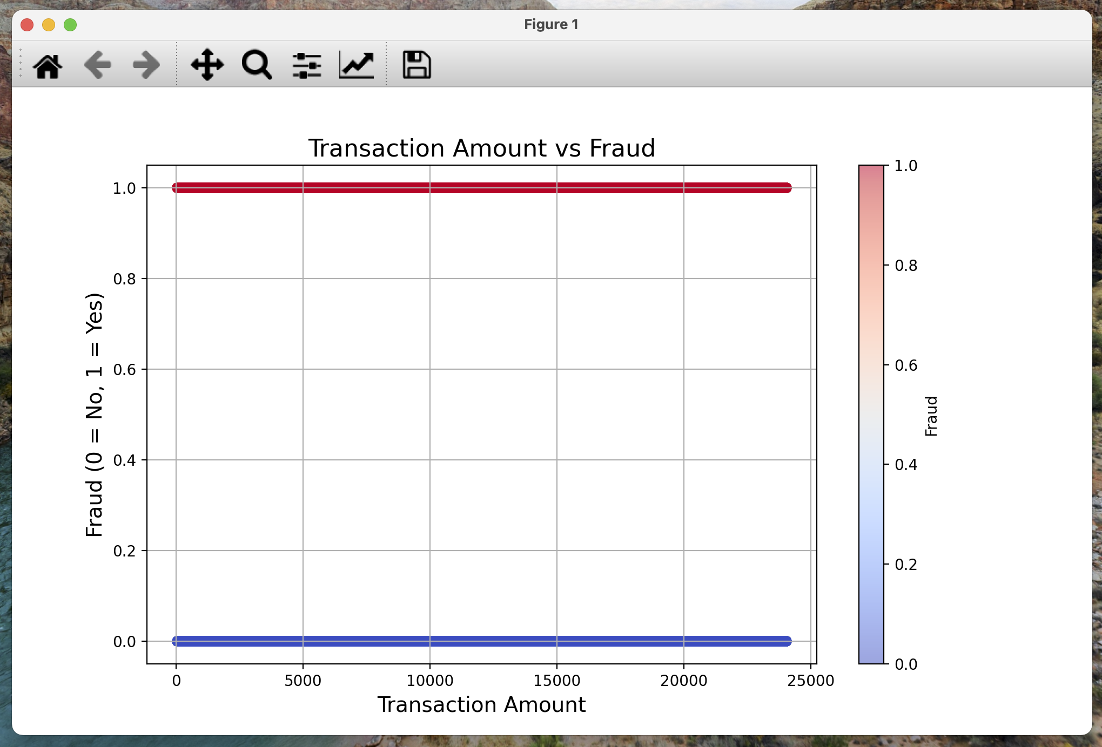
Figure 1: Graph of an Interesting Trend

Part 3: Naïve Bayes
Brief overview goes here. Describe the testing/training splits (% for each group). How many runs were averaged together?
Answer
The Naïve Bayes classifier was evaluated using 5-fold cross-validation. The data was normalized, and the results were averaged over 5 runs.
 | Mean Accuracy | Mean f1
naïve Bayes Test | 0.93 | 0.93

Discussion
What do you conclude? Is your K-NN implementation correct or do the results show that it is not working correctly? If it’s not working correctly, say something about what the problem might be.
Answer
The custom k-NN implementation performed similarly to scikit-learn's k-NN, with accuracies of 0.97, 0.96, and 0.95 for k=1, k=3, and k=5, respectively. This suggests that the custom implementation is correct and works as expected. The slight differences in accuracy are likely due to minor implementation details, such as the handling of ties in voting.
Are there clear winners or losers for kNN? Give some solid ideas for why some versions might be better or not better than others. Be as specific as you can, and reference the properties of your data set. Which configuration of k-NN would you recommend and why?
Answer
For k-NN, the best performance was achieved with k=3 and weights=distance, using the Manhattan distance (p=1), which yielded an average accuracy of 0.97 and an F1 score of 0.97. This configuration likely performed better because the distance weighting scheme gives more importance to closer neighbors, which is beneficial for datasets with varying feature scales. The Manhattan distance also performed slightly better than Euclidean distance, possibly because it is less sensitive to outliers.

How did the Naïve Bayes perform vs. the best of kNN? Give some solid ideas for why it did better or worse. Be as specific as you can and reference the properties of your data set. Would you recommend Naïve Bayes for this task, or should we stick with the k-NN recommendation? Why?
Answer
Naïve Bayes achieved an average accuracy of 0.93 and an F1 score of 0.93, which is slightly lower than the best k-NN configuration. This is likely because Naïve Bayes assumes feature independence, which may not hold true for this dataset. However, Naïve Bayes is computationally faster and could be a good choice if speed is a priority.

Final Recommendation
The best-performing model is k-NN with k=3, weights=distance, and p=1 (Manhattan distance), achieving an average accuracy of 0.97 and an F1 score of 0.97. This configuration is recommended for its high accuracy and robustness. While Naïve Bayes is faster, its slightly lower performance makes it less suitable for this task unless computational efficiency is a critical concern.

